**JOBSHEET 6**

**Selection Part 2**



**Name**

Sherly Lutfi Azkiah Sulistyawati

**NIM**

2341720241

**Class**

1I

**Department**

Information Technology

**Study Program**

D4 Informatics Engineering

Labs Activity

**Question! (Experiment 1)**

1. What is the output if the input is 2100? Please explain your answer! How to ensure that output complies with regulations (2100 is not a leap year)?
2. Modify the program according to answer number 1!
3. Commit and push the changes into your repository!
4. The year 2000 is a multiple of 4 and a multiple of 100, but it is a leap year. So that, there is an additional rule to determine leap year. If the year is a multiple of 100 and is also a multiple of 400 then that year is a leap year. Modify the program to adjust to these rule! (Create the algorithm without using logical operators)
5. Commit and push the modifications to the repository!

**Answer!**

1. The output will be “Not a leap year”, but it would incorrectly indicate that it is a leap year. This is because the code only checks for divisibility by 4 and non-divisibility by 100, but it does not account for years that are divisible by both 100 and 400.
2. 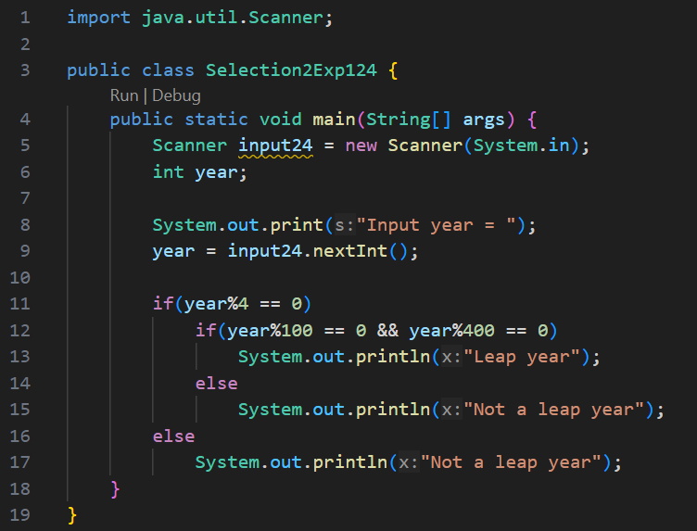
3. 

**Question! (Experiment 2)**

1. Modify the source code, so that it can detect the other types of triangles (equilateral triangle and isosceles triangle)
2. Commit and push the changes into your repository.

**Answer!**

1. 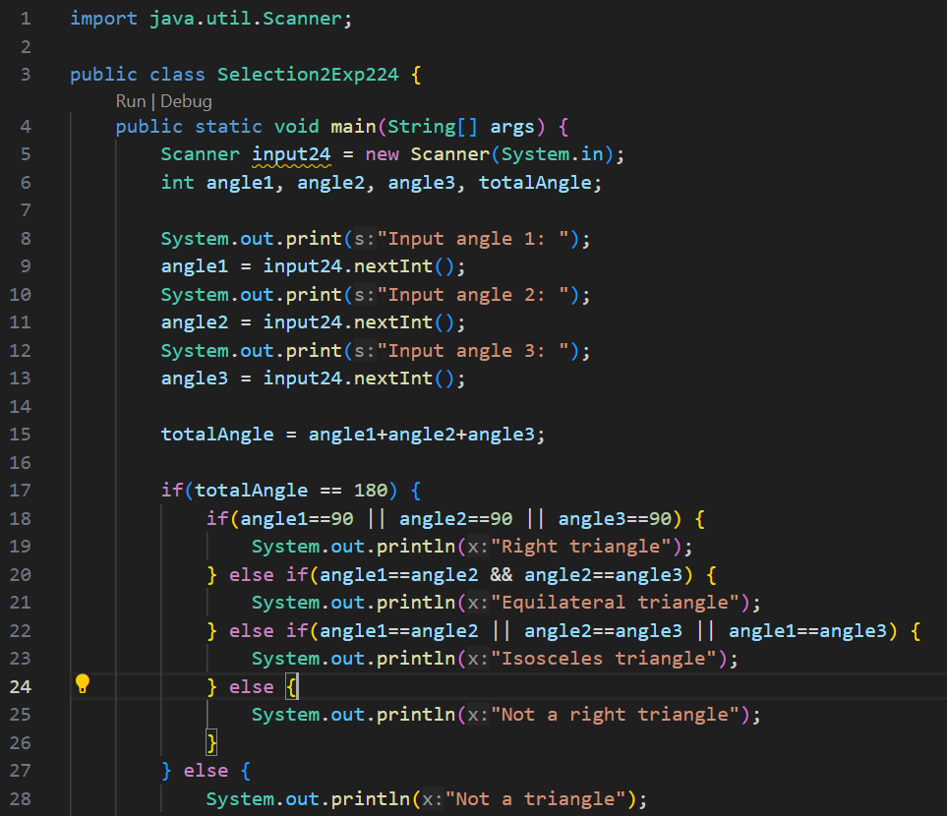

**Question! (Experiment 3)**

1. Explain the function of **(int)** in the syntax **netSalary= (int) (income - (income * tax));**
2. Run the program by entering **category = BUSINESSMAN** and **income = 2000000.** Observe what happens! What is the use of **equalsIgnoreCase**?
3. Change **equalsIgnoreCase** to **equals**, then run the program by entering **category = BUSINESSMAN** and **income = 2000000**. Observe what happens! Why is the result like that? What is the use of **equals**?

**Answer!**

1. In the syntax netSalary = (int) (income - (income * tax));, (int) is used for type casting, specifically casting the result of the expression (income - (income * tax)) to an int data type.
2. equalsIgnoreCase performs a case-insensitive comparison, ignoring the case differences in the strings.
3. equals performs a case-sensitive comparison, so it only considers two strings equal if they have the exact same characters in the exact same case.

**Assignment**

**Time: 160 Minutes**

Create a program code based on the flowchart that was created in the 6th Fundamentals Programming Course meeting assignment related to the Project! Push and commit the results of your program code to your project repository! Note: assignments may only apply material from meeting 1 to meeting 6.

**Answer!**

